**Homework 4**

**IM/2019/066**

**G.W.S.Hasarinda**

**Q1)**

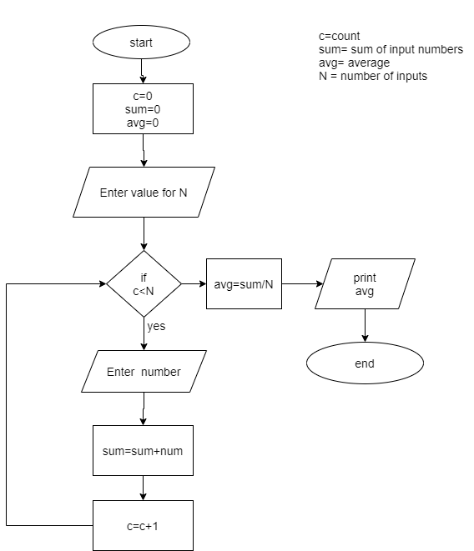

/*This program that reads a value of N and then compute the average of the Next

N elements of inputs*/

#include <iostream>

using namespace std;

int main(){

int num;

cout<<"Enter count of Numbers-"<<endl;

cin>>num;

int count=1;

int sum=0;

int n;

double avg; //average

while(count<=num)

{

cout<<"Enter Number"<<count<<"-"<<endl;

cin>>n; //input number

sum=sum+n;

count++;

}

avg=sum/count;

cout<<"Average is="<<avg<<endl;

return 0;

}

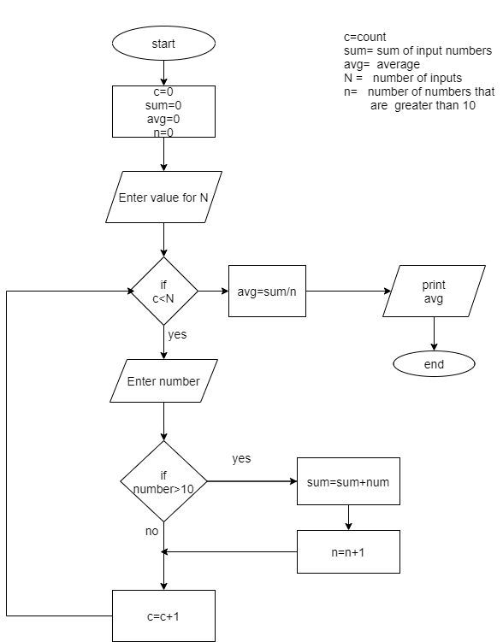**Q2)**

//computes only the average input items that are greater than 10

#include <iostream>

using namespace std;

int main(){

int sum = 0;

int input =0;

int num = 1;

int n = 0;

double Avg,

cout<< "Input number"<<endl;

cin>>n;

while(num <= n)

{

cout<<"Input Number of Values "<< num<<": ";

cin>>input;

if(input>10)

{

sum = sum + input;

}

num++;

}

Avg = sum/n;

cout << "Average is :"<<Avg;

return 0;

}

**Q3)**

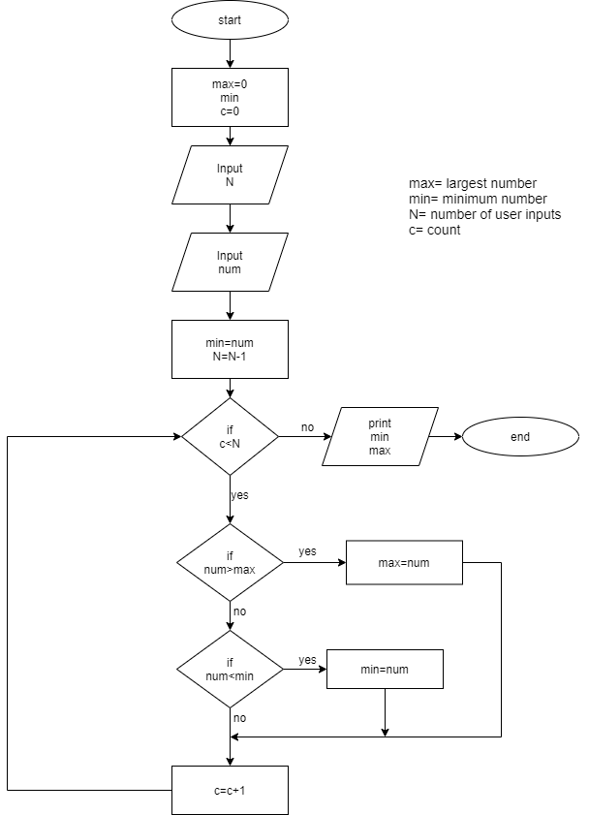

//computes the smallest and the largest numbers in the next N elements of inputs

#include <iostream>

using namespace std;

int main()

{

int n,max,min,num,count = 1;

cout<<"Input N Value= ";

cin>>n;

while (count<=n){

cout<<"Input a Number "<<count<< ":";

cin>>num;

if (count==1){

max=num;

min=num;

}else{

if (num>=max){

max= num;

}

if (num<=min)

{

min= num;

}

}

count++;

}

cout<<"Maximum value is = "<<max<<"\n";

cout<<"Minimum value is = "<<min;

return 0;

}

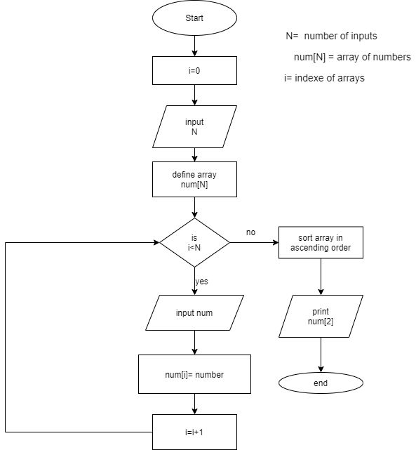**Q4)**

//Computes the 3RD smallest number in the next N elements of inputs

#include <iostream>

using namespace std;

int main() {

int N , count ;

count = 0;

getcount:

cout << "Enter the number of numbers to enter : " ;

cin >> N ;

if(N<3){

cout << "Enter valid number of inputs" << endl ;

goto getcount ;

}

double nums[N] ;

while (count < N){

cout << "Enter the number " << count+1 <<" : ";

cin >> nums[count] ;

count++ ;

}

for (int i = 0;i < N; i++ ){

for (int j = i+1;j<N;j++){

if(nums[i]>nums[j]){

int temp = nums[i];

nums[i] = nums[j];

nums[j] = temp;

}

}

}

cout << "3RD smallest number is : " << nums[2] << endl ;

return 0;

}

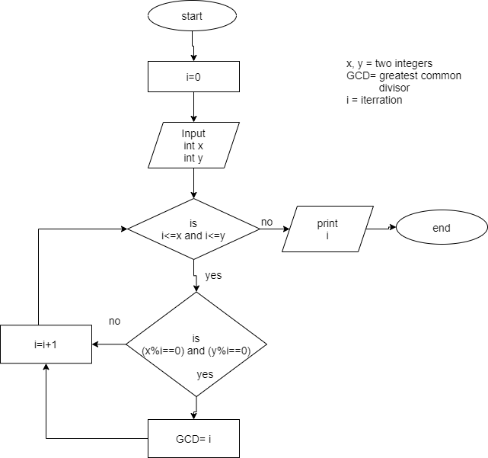**Q5)**

//compute the greatest common divisor of two integers

#include<iostream>

using namespace std;

int main()

{

int n1; //number 1

int n2; //number 2

int x;

int GCD; //Great common divisor

cout<<"enter first integer:";

cin>>n1;

cout<<"enter second integer:";

cin>>n2;

for(x=1;x<=n1 && x<=n2;++x)

{

if(n1%x==0 && n2%x==0)

{

GCD=x;

}

}

cout<<"greatest common divisor:"<<GCD<<endl;

return 0;

}

**Q6)**

//compute the smallest common factor of two integers

#include<iostream>

using namespace std;

int main(){

int n1;

int n2;

int scf; //small common factor

int gcd; //greatest common divisor

int i;

cout<<"input first integer:"; //input first integer and second integer

cin>>n1;

cout<<"input second integer:";

cin>>n2;

for(i=1;i<=n1 && i<=n2;i++)

{

if (n1%i==0 && n2%i==0) //calculation of gcd

{

gcd=1;

}

}

scf=(n1*n2)/gcd; //calculation of scf

cout<<"smallest common factor:"<<scf<<endl;

}